GUIDE

-Importing the libraries

-Importing the Dataset

-Missing Data

-Categorical Data

-Splitting Data

-Feature Scaling
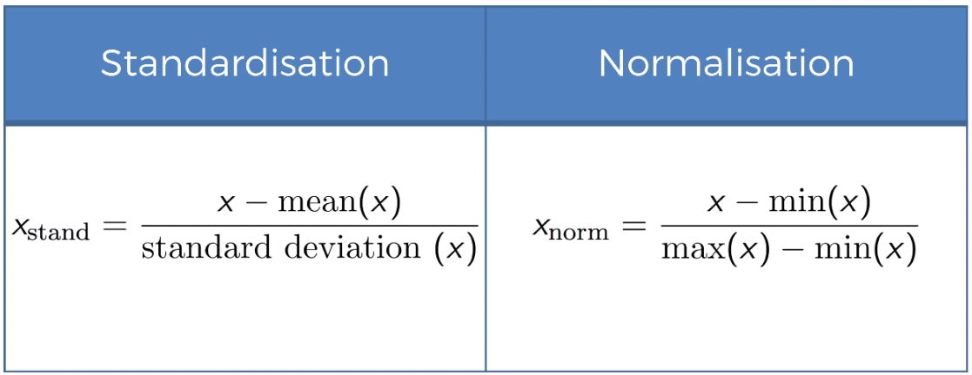

-Data Preprocessing

